***3:*** ***Joins and View***

Note: Tables created and data inserted in Exercise 2 are attached in appendix.

**Exercise 5:**

# Display the employee who is getting highest salary in the department Research.

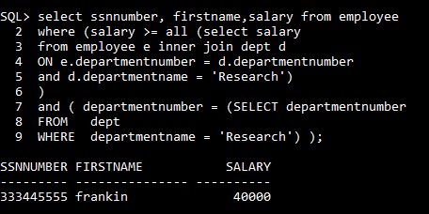

# Find the employees who earn the same salary as the minimum salary for each department.

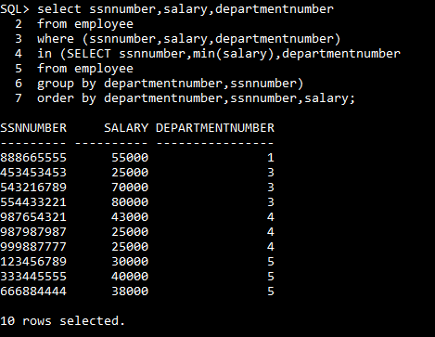

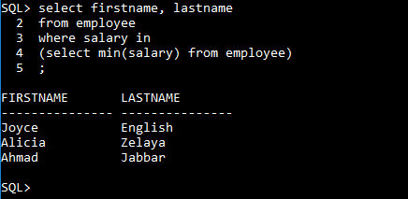

# Retrieve the employees whose salary is greater than average salary of department 2.

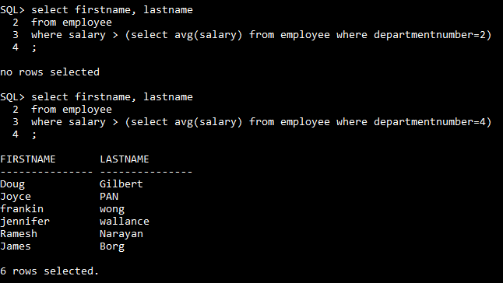

Since there is no employee registered under department 2(as per table shown on page 1), query gives “no rows selected” as a result. It is not in case of department 4.

# List out the employee that has got maximum number of dependents.

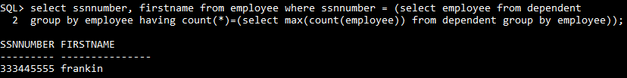

# Find out the project name having least number of employees working on it.

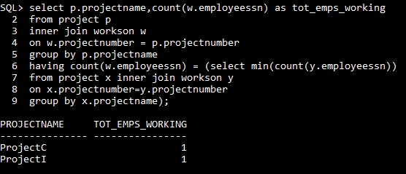

# Find minimum average salary for each department.

**Method 1: Using Join**

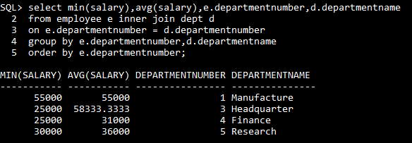

**OR**

**Method 2: Using Aggregate functions only**

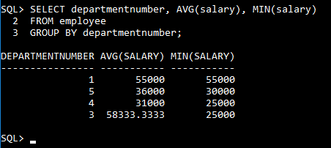

# Create a view to display the employee details who is working in either Finance or Research department.

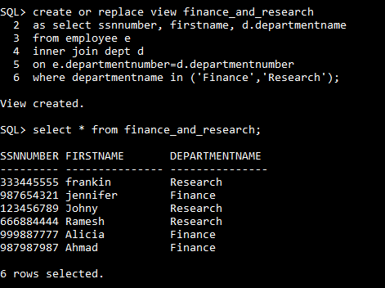

# Create a logical table to store male employee details ranging salary between 20000 and 30000.

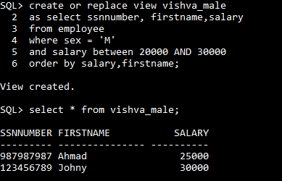

# Create a logical table to store employee number who works on maximum number of projects.

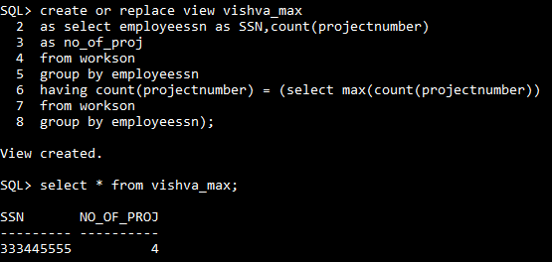

End of Exercise 5

**Exercise 6**

# Display the names of all employees in department 5 who work more than 10 hours per week on ProjectX project.

By considering ProjectX as ProjectA. Since ProjectX is not given in data entered in the table before [see appendix for tables].

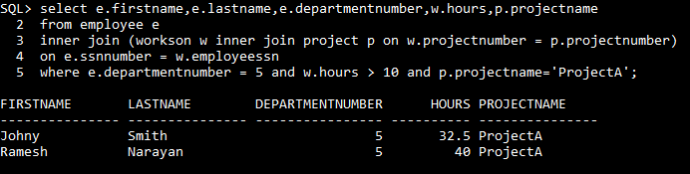

By applying all given conditions for all projects:

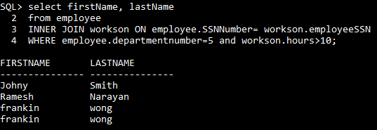

# List the names of all employees who have a dependent with the same first name as themselves.

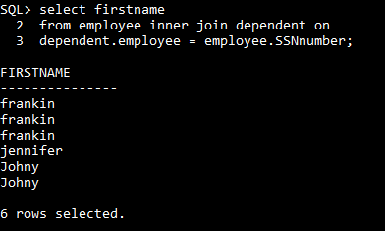

# Find the names of all the employees who are directly supervised by ‘Frankin Wong’.

**Method 1: using join**

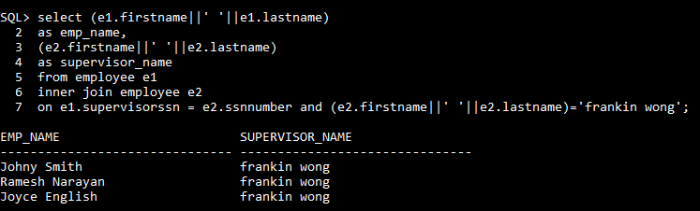

**OR**

**Method 2: Using subquery**

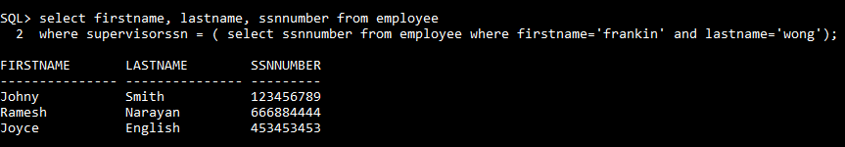

# Retrieve the names of all who do not work on any project.

**Method 1: Using Join**

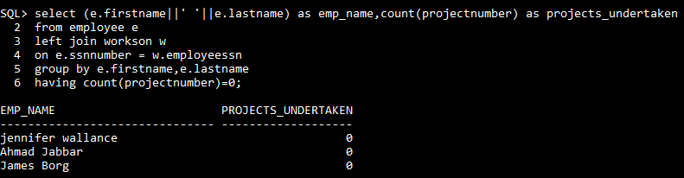

**OR**

**Method 2: Using subquery**

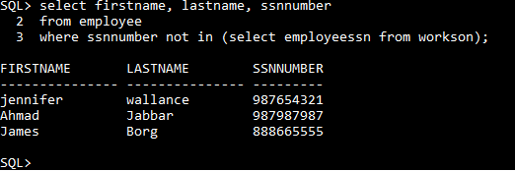

# Find the names and addresses of all employees who work on at least one project located in Houston but whose department has no location in Houston.

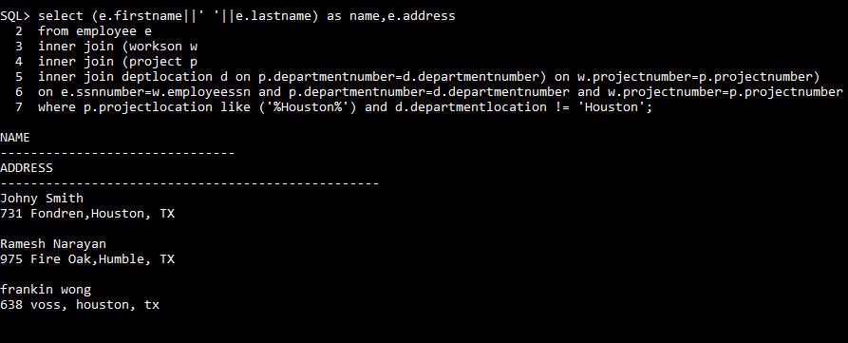

# Display the names of all managers who have no dependents.

**Method 1: Using Join**

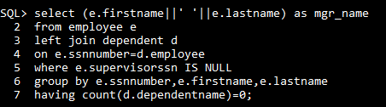

**Method 1: Using Subquery**

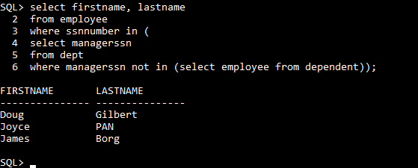

# List the employee’s names and the department names if they happen to manage a department.

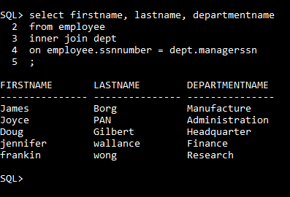

# For each department retrieve project number, and project name.

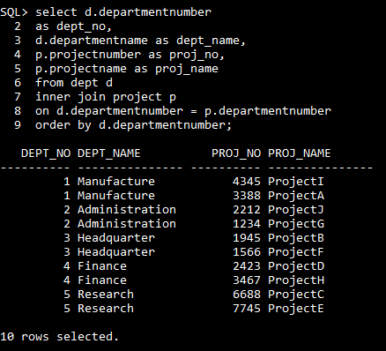

# For each project, list the project name and the total hours per week (by all employees) spent on that project.

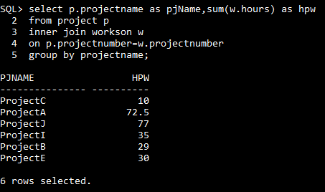

# Get the names of the employees who have 2 or more dependents.

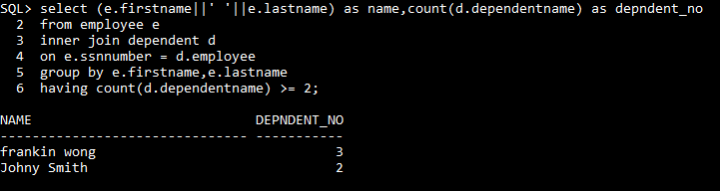

End of Exercise 6

**Appendix**

Table employee: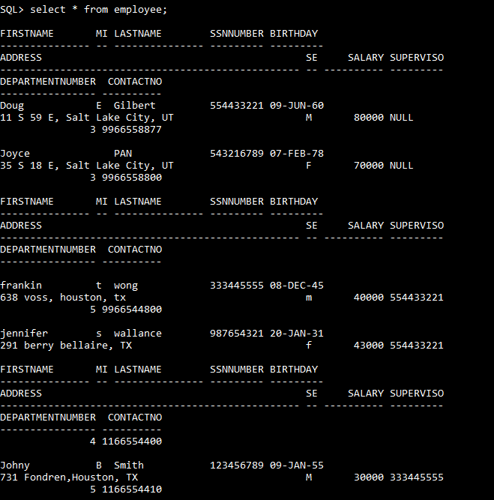

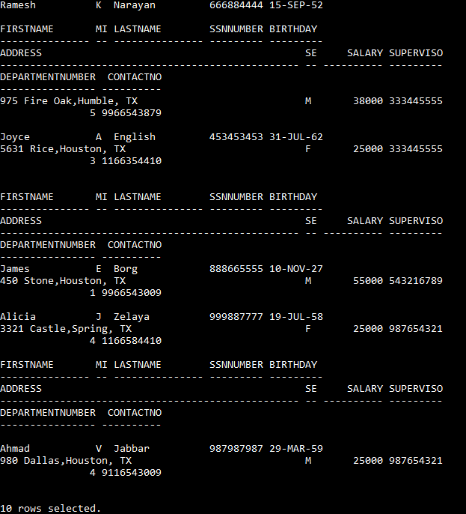

Table dept:

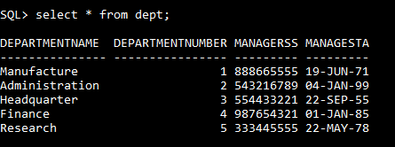

Table dependent:

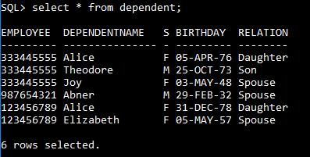

Table workson:

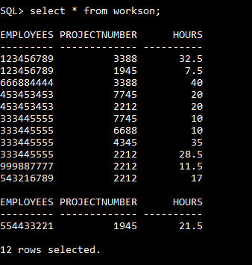

Table deptlocation

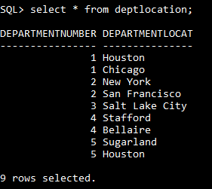

Table project

